https://jira.tcsbank.ru/browse/INCR-627
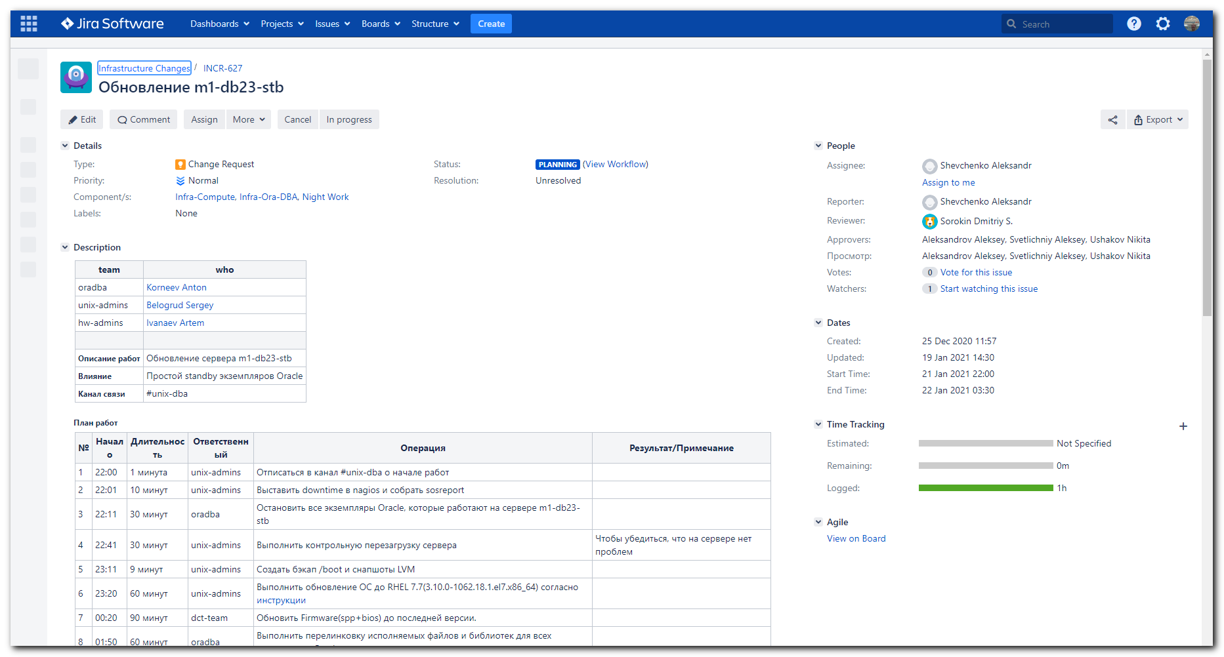

План работ
№ | Начало | Длительность | Ответственный | Операция | Результат/Примечание
1 | 22:00 | 1 минута | unix-admins | Отписаться в канал #unix-dba о начале работ
2 | 22:01 | 10 минут | unix-admins | Выставить downtime в nagios и собрать sosreport
3 | 22:11 | 30 минут | oradba | Остановить все экземпляры Oracle, которые работают на сервере m1-db23-stb
4 | 22:41 | 30 минут | unix-admins | Выполнить контрольную перезагрузку сервера | Чтобы убедиться, что на сервере нет проблем
5 | 23:11 | 9 минут | unix-admins | Создать бэкап /boot и снапшоты LVM
6 | 23:20 | 60 минут | unix-admins | Выполнить обновление ОС до RHEL 7.7(3.10.0-1062.18.1.el7.x86_64) согласно инструкции
7 | 00:20 | 90 минут | dct-team | Обновить Firmware(spp+bios) до последней версии.
8 | 01:50 | 60 минут | oradba | Выполнить перелинковку исполняемых файлов и библиотек для всех экземпляров Oracle
9 | 02:50 | 30 минут | oradba | Запустить экземпляры Oracle
10 | 03:20 | 10 минут | unix-admins | Проверить логи ОС на наличие ошибок
11 | 03:30 | 1 минута | unix-admins | Снять downtime в nagios
12 | 03:11 | 1 минута | unix-admins | Отписаться в канал #unix-dba об окончании работ
В случае возникновения проблем, которые не позволяют выполнить работы, перейти к плану отката

План отката
№ | Длительность | Ответственный | Операция | Результат/Примечание
1 | 20 минут | unix-admins | Откатить снапшоты LVM и перезагрузить сервер m1-db23-stb
2 | 60 минут | oradba | Выполнить перелинковку исполняемых файлов и библиотек для всех экземпляров Oracle
3 | 30 минут | oradba | Запустить экземпляры Oracle
4 | 10 минут | unix-admins | Проверить логи ОС на наличие ошибок
5 | 1 минута | unix-admins | Отписаться в канал #unix-dba об окончании работ

[15:54:47 root@m1-db23-stb ~]# findmnt -t nfs -o TARGET | grep -ie "oramnt" | sed -e 's/^\/oramnt\///'
BPM_prod_arch
FILENET_prod_arch
listener_prod
ESB_MSGS
CREDB
ESB
INFORM_prod_arch
ESB_prod_arch
SIEBEL_prod_arch
FILENET
XXI_prod_arch
TI_GW_prod_arch
SASAUX
SSO
TI_GW
DFINANS
SSO_prod_arch
DFINANS_prod_arch
INFORM
SIEBEL
BB_DTA
ILOG_BPM
EDA
ESB_MSGS_prod_arch
XXI_MFO_prod_arch
ILOG_BPM_prod_arch
XXI
SASAUX_prod_arch
BB_DTA_prod_arch
BPM
EDA_prod_arch
XXI_MFO
CREDB_prod_arch
AML_prod_arch
AML
AVAYA_prod_arch
AVAYA
BSS17_prod_arch
BSS17
BUFF_prod_arch
BUFF
CRYPTO_prod_arch
CRYPTO
EMREP_prod_arch
EMREP
EVAM_prod_arch
EVAM
HRSPACE_prod_arch
HRSPACE
LOYALTY_prod_arch
LOYALTY
REPORTS_prod_arch
REPORTS
RMCAT
RMCAT_prod_arch
SD_prod_arch
SD
SPAREPRM_prod_arch
SPAREPRM
WFM_prod_arch
WFM
WOF_prod_arch
WOF
TRADE_prod_arch
RSTINK_prod_arch
RSTINK
XLTINK_prod_arch
XLTINK
TRADE
SME_prod_arch
PRM_prod_arch
PRM
RSC
RSC_prod_arch
SME
rmanbackups
ohbackups
ACC
ACC_prod_arch
[15:55:08 root@m1-db23-stb ~]#

#
# All licences were used.
#

[16:05:53 root@m1-db23-stb ~]# subscription-manager status
+-------------------------------------------+
System Status Details
+-------------------------------------------+
Overall Status: Unknown

[16:06:39 root@m1-db23-stb ~]# subscription-manager list
+-------------------------------------------+
Installed Product Status
+-------------------------------------------+
Product Name: Red Hat Enterprise Linux Server
Product ID: 69
Version: 7.5
Arch: x86_64
Status: Unknown
Status Details:
Starts:
Ends:

[16:07:12 root@m1-db23-stb ~]# egrep -e "^proxy_hostname|^proxy_port|^proxy_user|^proxy_password" /etc/rhsm/rhsm.conf
proxy_hostname =proxy.tcsbank.ru
proxy_port =8080
proxy_user =rhsm_user
proxy_password =6eKoEvNHFS5IycxhqH5W
[16:07:28 root@m1-db23-stb ~]# read -s -p "Enter RHN Password: " RHN_PASSWORD ; subscription-manager register --username=tcsbank17012012 --password=$RHN_PASSWORD --auto-attach
Enter RHN Password: Registering to: subscription.rhsm.redhat.com:443/subscription
The system has been registered with ID: fd612839-f321-4d83-b7ca-45cb6f094dde
The registered system name is: m1-db23-stb
Installed Product Current Status:
Product Name: Red Hat Enterprise Linux Server
Status: Not Subscribed

Unable to find available subscriptions for all your installed products.
[16:08:44 root@m1-db23-stb ~]# subscription-manager status
+-------------------------------------------+
System Status Details
+-------------------------------------------+
Overall Status: Invalid

Red Hat Enterprise Linux Server:
- Not supported by a valid subscription.

[16:10:02 root@m1-db23-stb ~]# read -s -p "Enter RHN Password: " RHN_PASSWORD ; subscription-manager register --username=tcsbank17012012 --password=$RHN_PASSWORD --auto-attach
Enter RHN Password: This system is already registered. Use --force to override
[16:11:11 root@m1-db23-stb ~]# subscription-manager status
+-------------------------------------------+
System Status Details
+-------------------------------------------+
Overall Status: Invalid

Red Hat Enterprise Linux Server:
- Not supported by a valid subscription.

[16:11:59 root@m1-db23-stb ~]# read -s -p "Enter RHN Password: " RHN_PASSWORD ; subscription-manager register --username=tcsbank17012012 --password=$RHN_PASSWORD --auto-attach --force
Enter RHN Password: Unregistering from: subscription.rhsm.redhat.com:443/subscription
The system with UUID fd612839-f321-4d83-b7ca-45cb6f094dde has been unregistered
All local data removed
Registering to: subscription.rhsm.redhat.com:443/subscription
The system has been registered with ID: 85c632f5-dc8e-4259-b597-6c9d3a1ded0a
The registered system name is: m1-db23-stb
Installed Product Current Status:
Product Name: Red Hat Enterprise Linux Server
Status: Not Subscribed

Unable to find available subscriptions for all your installed products.
[16:12:56 root@m1-db23-stb ~]#

https://access.redhat.com/management/systems/cd35fb5a-2317-4503-b14b-3e97b3d88c18/subscriptions
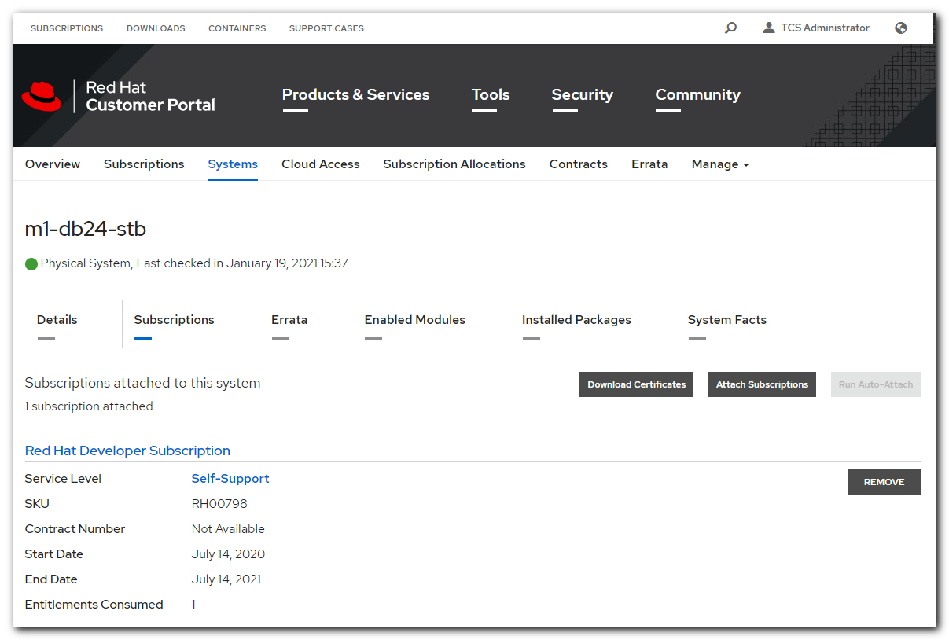

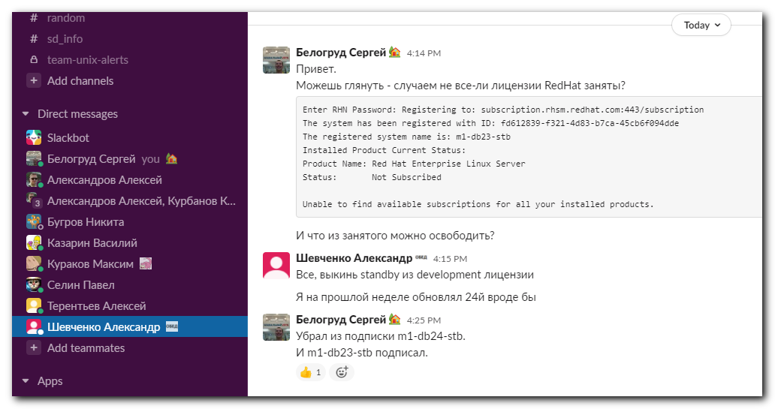

................................................................................

[s.belogrud@TCS4357]# ssh bsv@m1-db24-stb
Last login: Thu Mar 5 21:13:09 2020 from tcs4357.tcsbank.ru
[bsv@m1-db24-stb ~]$ sudo -i
[sudo] password for bsv:
Sorry, try again.
[sudo] password for bsv:
[16:19:46 root@m1-db24-stb ~]# subscription-manager status
+-------------------------------------------+
System Status Details
+-------------------------------------------+
Overall Status: Current

System Purpose Status: Not Specified

[16:20:03 root@m1-db24-stb ~]# subscription-manager remove --all && subscription-manager unregister
1 local certificate has been deleted.
1 subscription removed at the server.
Unregistering from: subscription.rhsm.redhat.com:443/subscription
System has been unregistered.
[16:22:48 root@m1-db24-stb ~]# subscription-manager status
+-------------------------------------------+
System Status Details
+-------------------------------------------+
Overall Status: Unknown

System Purpose Status: Unknown

[16:23:59 root@m1-db24-stb ~]#

................................................................................

[16:22:57 root@m1-db23-stb ~]# read -s -p "Enter RHN Password: " RHN_PASSWORD ; subscription-manager register --username=tcsbank17012012 --password=$RHN_PASSWORD --auto-attach --force
Enter RHN Password: Unregistering from: subscription.rhsm.redhat.com:443/subscription
The system with UUID 85c632f5-dc8e-4259-b597-6c9d3a1ded0a has been unregistered
All local data removed
Registering to: subscription.rhsm.redhat.com:443/subscription
The system has been registered with ID: 4b7c54f1-4651-415e-be5c-5a38d3ccc6e4
The registered system name is: m1-db23-stb
Installed Product Current Status:
Product Name: Red Hat Enterprise Linux Server
Status: Subscribed

[16:23:44 root@m1-db23-stb ~]#

................................................................................
#
# And now the server m1-db24-stb is absent here
#
https://access.redhat.com/management/systems
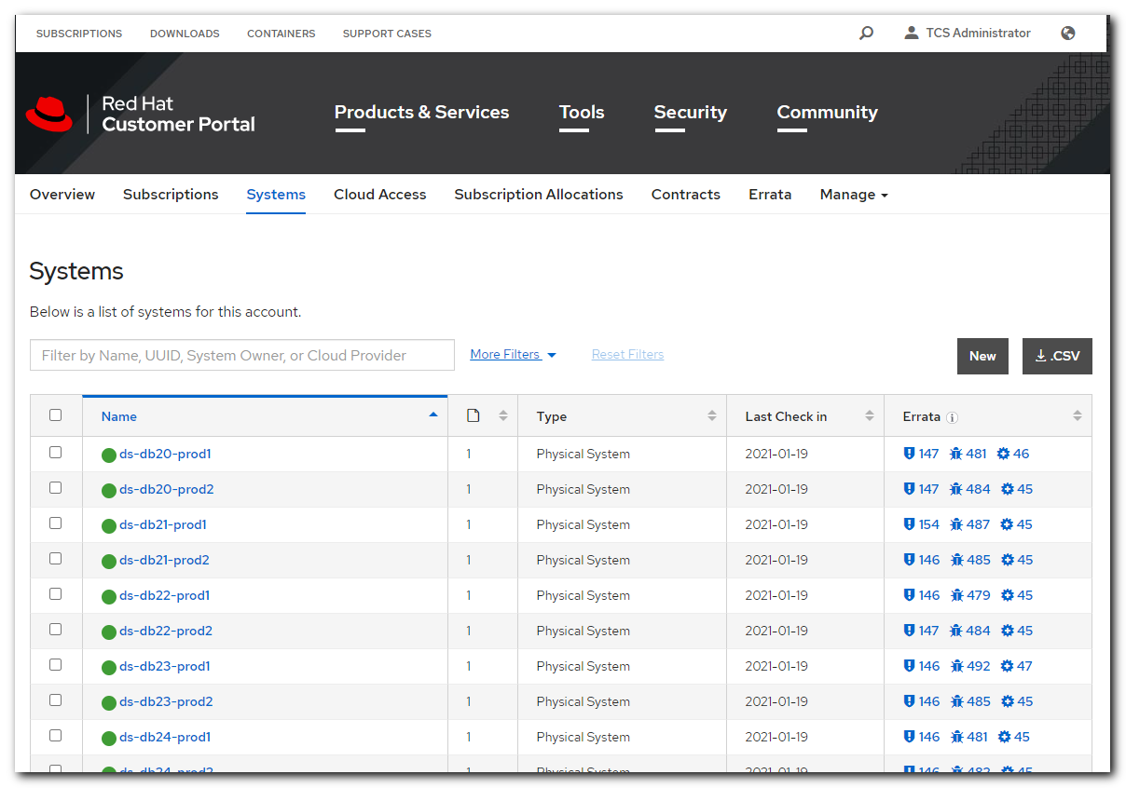

[16:26:58 root@m1-db23-stb ~]# subscription-manager list
+-------------------------------------------+
Installed Product Status
+-------------------------------------------+
Product Name: Red Hat Enterprise Linux Server
Product ID: 69
Version: 7.5
Arch: x86_64
Status: Subscribed
Status Details:
Starts: 07/14/2020
Ends: 07/14/2021

[16:33:59 root@m1-db23-stb ~]#

[16:33:59 root@m1-db23-stb ~]# subscription-manager release --list
+-------------------------------------------+
Available Releases
+-------------------------------------------+
7.0
7.1
7.2
7.3
7.4
7.5
7.6
7.7
7.8
7.9
7Server
[16:34:55 root@m1-db23-stb ~]#

[16:34:55 root@m1-db23-stb ~]# yum list kernel --show-duplicates --disablerepo="*" --enablerepo="rhel-7-server-rpms" | head
Loaded plugins: langpacks, product-id, search-disabled-repos, subscription-
: manager
Repodata is over 2 weeks old. Install yum-cron? Or run: yum makecache fast
Installed Packages
kernel.x86_64 3.10.0-693.17.1.el7 @anaconda/7.4
kernel.x86_64 3.10.0-862.14.4.el7 @rhel-7-server-rpms
Available Packages
kernel.x86_64 3.10.0-123.el7 rhel-7-server-rpms
kernel.x86_64 3.10.0-123.1.2.el7 rhel-7-server-rpms
kernel.x86_64 3.10.0-123.4.2.el7 rhel-7-server-rpms
kernel.x86_64 3.10.0-123.4.4.el7 rhel-7-server-rpms
[16:35:34 root@m1-db23-stb ~]#

[17:56:58 root@m1-db23-stb ~]# export rootvg=$(lvs --noheadings -o vg_name -S lv_dm_path=`findmnt -r -n -o SOURCE /`| tr -d ' ')
[17:57:05 root@m1-db23-stb ~]# vgs -S vg_name=$rootvg
VG #PV #LV #SN Attr VSize VFree
rootvg 1 5 0 wz--n- 1.09t 442.56g
[17:57:42 root@m1-db23-stb ~]#

По причине проведения ночных работ “Обновление m1-db23-stb” (https://jira.tcsbank.ru/browse/INCR-627) с 22:00 21.01.2021 по 3:00 22.01.2021 планирую подключиться в пятницу к работе позже на ~5 часов.

